## **EXPERIMENT NO. 6**

**Aim:** Develop Structure based social media analytics model for any business. (e.g. Structure Based Models - community detection, influence analysis)

**Theory:**

**Structure based social media analytics:**

Developing a structure-based social media analytics model for any business is a critical step in understanding the network of their audience and identifying influential users. Structure-based social media analytics is a process of analyzing the social network structure of a business or its customers. It helps businesses to understand the relationships between their audience and identify influential users. Structure-based analysis can be used for community detection and influence analysis.

* **Community Detection**: It is the process of identifying groups or communities of users within a social network. This can help businesses to understand the interests and preferences of different user groups and create targeted content to improve engagement.
* **Influence Analysis**: It is the process of identifying influential users within a social network. This can help businesses to identify users who have a significant impact on their audience and engage with them to improve their social media presence.

**NetworkX API in Python:**

NetworkX (NX) is a Python package for the creation, manipulation, and study of the structure, dynamics, and functions of complex networks. Centrality measures are a vital tool for understanding networks, often also known as graphs. These algorithms use graph theory to calculate the importance of any given node in a network. They cut through noisy data, revealing parts of the network that need attention – but they all work differently. There are four well-known centrality measures: degree, betweenness, closeness and eigenvector - each with its own strengths and weaknesses.

1. **Degree Centrality:**

* To display the degree of each node in graph: nx.degree(G).
* For computing degree centrality of each node: nx.degree_centrality(G).

1. **Closeness Centrality:**

* Find the shortest path from the given node to other node nx.shortest_path(G,’7’,’9’).

1. **Betweenness centrality:**

* Measures how important a node is to the shortest path through the network nx.betweenness_centrality(G).

1. **Eigenvector centrality:**

* Measures a node’s importance.
* Links from important nodes.
* Node’s influence nx.eigenvector_centrality(G).

**Code:**

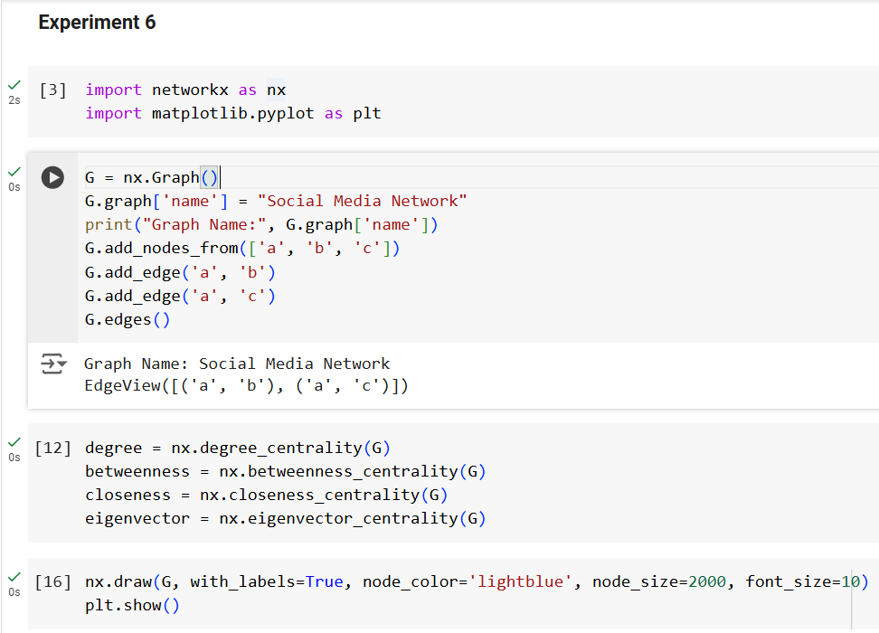

**Output:**

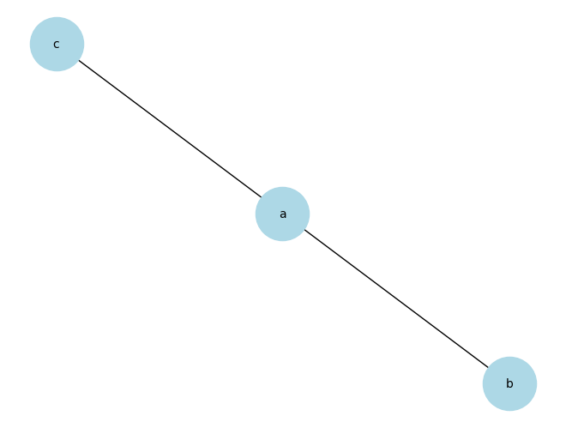

**Conclusion:**

Thus, successfully developed Structure based social media analytics model for a business using NetworkX API which is a python package capable of manipulating and studying network graphs.